Experiment 5: Missionaries and Cannibals Problem

AIM
To develop a Python program to solve the Missionaries and Cannibals Problem using the Breadth First Search (BFS) algorithm.

OBJECTIVE
To demonstrate that the Breadth First Search (BFS) algorithm can safely transport all missionaries and cannibals across the river without violating the given constraints.

ALGORITHM
- Start.
- Initialize the initial state with 3 missionaries, 3 cannibals, and the boat on the left bank.
- Generate all valid successor states by moving one or two people across the river while ensuring missionaries are never outnumbered by cannibals on either bank.
- Continue exploring valid states using Breadth First Search (BFS) until all missionaries and cannibals reach the right bank safely.
- Display the solution path and
- Stop.

SAMPLE CODE
from collections import deque

def is_valid(m_left, c_left):
m_right = 3 - m_left
c_right = 3 - c_left

if m_left < 0 or c_left < 0 or m_left > 3 or c_left > 3:
return False

if m_left > 0 and c_left > m_left:
return False
if m_right > 0 and c_right > m_right:
return False
return True
def bfs():
start = (3, 3, 'L')
goal = (0, 0, 'R')
queue = deque([(start, [])])
visited = set()

moves = [(1,0), (2,0), (0,1), (0,2), (1,1)]
while queue:
state, path = queue.popleft()
if state in visited:
continue
visited.add(state)
path = path + [state]
if state == goal:
return path
m, c, boat = state
for dm, dc in moves:
if boat == 'L':
new_state = (m-dm, c-dc, 'R')
else:
new_state = (m+dm, c+dc, 'L')
if is_valid(new_state[0], new_state[1]):
queue.append((new_state, path))
solution = bfs()
print("Solution Path:")
for step in solution:
print(step)
FLOW CHART
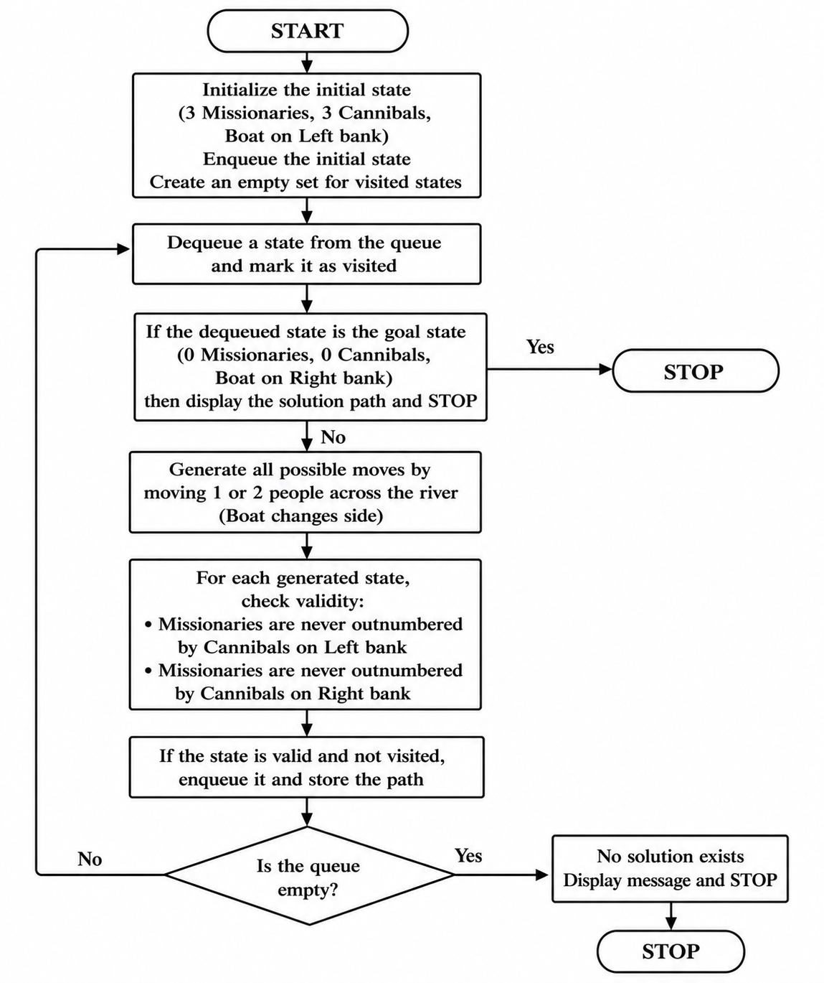
OUTPUT
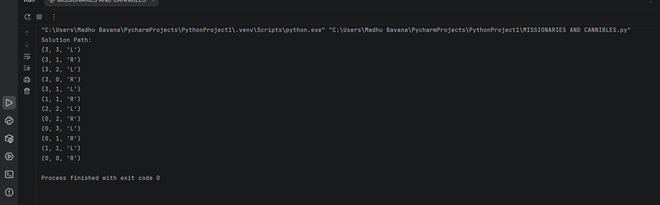
RESULT
The Python program was executed successfully. The Breadth First Search (BFS) algorithm found a valid sequence of moves to safely transport all missionaries and cannibals across the river without violating the problem constraints.

